BTC 313 LECTURE NOTE

DNA FINGERPRINTING

DNA fingerprinting is a laboratory technique used to determine the identity of an individual based on unique regions of the human genome. Also called DNA profiling or DNA typing, this method relies on the unique pattern found in different individuals when a series of DNA fragments is separated according to length. This technique was discovered in 1985 by Alec Jeffreys and was first used in a criminal investigation in 1986.

Principle of DNA fingerprinting

The DNA of every human being is 99.9% the same. However, about 0.1% or 3 x 10⁶bp DNA is unique in every individual. DNA fingerprinting relies on the inherent genetic variations present in an individual's DNA. These variations, known as polymorphisms, are unique to each person. The technique focuses on specific regions of the DNA containing repetitive sequences, variable number tandem repeats (VNTRs) or short tandem repeats (STRs). These regions occur in non-coding regions of the DNA and varies in the number of repeats between individuals. VNTRs also called minisatellites are allelic variants that consist of tandem repeats of 9 to 80 base pairs in length while STRs a subcategory of VNTRs has repeats of 2 to 6 bases long.

Methods of DNA Fingerprinting

The two widely used methods in DNA fingerprinting are:

- Restriction fragment length polymorphism (RFLP)-based fingerprinting
- Polymerase chain reaction (PCR) amplification of short tandem repeats (STRs)
- Restriction Fragment Length Polymorphism (RFLP): The earliest form of DNA fingerprinting, this method has opened the door for new developments in the field. An RFLP is a sequence of DNA that has a restriction site on each end with a “target” sequence in

between. A target sequence is any segment of DNA that can bind to a probe by forming complementary base pairs.
Procedure

- First isolate purified DNA from the sample material to be tested. The sample size for RFLP must be large enough to get a proper result.
- Next, Cut/digest the isolated DNA using restriction enzymes.
- Separate the digested DNA sample by gel electrophoresis by length or molecular weight.
- Visualize fragments using southern blotting by
  - Transferring the separated fragments from the gel to a solid membrane (nitrocellulose or nylon)
  - Hybridize the membrane with a radioactive labeled DNA probe specific for VNTR regions which binds to the complementary DNA fragments.
  - After hybridization, place an x-ray film in contact with the solid membrane to detect the patterns from the probe which shows as dark bands when the x-ray film is developed.
- Compare bands gotten between each sample.

Advantages

The RFLP is considered more accurate than the PCR method, because it uses more sample, makes use of fresh DNA sample, and has no amplification contamination.

Disadvantages

It requires is expensive to perform and time consuming.

A relatively large amount of sample is required to perform the tests.

This method requires high molecular weight, un-degraded DNA which could be a challenge in forensic investigations.

- Polymerase Chain Reaction (PCR) amplification of short tandem repeats (STRs) – This method requires already known STR sequences in order to design primers that will specifically hybridize to the target DNA.

Procedure

- Isolate the DNA from the samples of interest.
- Amplify using PCR with a known series of STR repeat sequence. For amplification, the primers are specifically designed to attach to a highly conserved common non-variable region of DNA flanking the variable region. Primer pairs are designed for each STR locus and a unique fluorescent tag added to the resulting PCR product
- Separate the DNA fragments using capillary electrophoresis.
o After amplification, the DNA sample is run through a capillary containing a gel that allows smaller STR sequences to travel faster through its pores. At the end of the capillary, a laser beam and detector register the fluorescent tag of each sequence thereby registering the length for each locus analyzed.
Advantages

  - Requires little amount of sample.
  - Less expensive to perform.
  - Less time consuming.

Disadvantages

- Possibility of amplification contamination.
- Less effective than RFLP fingerprinting

Application of DNA Fingerprinting

- Paternity testing
- Tracing of family ancestry
- DNA profiling: Identification of victims; plane accident, explosions etc.
- Forensic DNA trace analysis
- Gene mapping
- Pre and post natal diagnosis of diseases.

RECOMBINANT DNA TECHNOLOGY

Recombinant DNA technology deals with the isolation and manipulation of genes. It is a laboratory technique that involves the use of enzymes and several laboratory techniques to isolate and combine DNA fragments (genes) from different sources or to create genes with new functions. The resultant product is called Recombinant DNA (rDNA). Recombinant DNA technology is also referred to as genetic engineering or gene manipulation.

History of Recombinant DNA Technology

Recombinant DNA technology was made possible after the discovery of restriction enzymes in 1968 by Swiss microbiologist Werner Arber.
The following year 1969, American microbiologist Hamilton O. Smith purified the type II restriction enzymes which is very essential to genetic engineering due to their ability to cleave a specific site within a DNA.
The first recombinant DNA molecule was made by Paul Berg in 1972 by combining DNA from the monkey virus SV40 with the lambda virus.
In 1973, Daniel Nathans, Hamilton Smith, and Werner Arber develop the technique of restriction mapping, allowing researchers to map the locations of restriction enzyme cleavage sites on DNA.
Also in 1973, Stanley Cohen and Herbert Boyer achieved the first successful gene cloning was achieved by in 1973 by inserting a gene from a toad into a plasmid and then introducing it into Escherichia coli (E. coli) bacteria.
In 1975, Edwin Southern developed a method for detecting specific DNA fragments from a complex mixture of isolated DNA. This method is known as Southern blotting.
In 1980 the first genetically engineered vaccine, for hepatitis B, was developed using recombinant DNA technology.
In 1983, Kary Mullis invented the polymerase chain reaction (PCR), a revolutionary technique for amplifying DNA segments, enabling their rapid and efficient replication.
In 1985, Yoshizumi Ishino and colleagues discover clustered regularly interspaced short palindromic repeats (CRISPR) in bacteria, laying the foundation for the revolutionary CRISPR-Cas9 gene-editing technology.

Steps in Recombinant DNA Technology

- DNA Isolation: DNA is isolated in its pure form through a DNA extraction process.
- Cutting of DNA/Restriction Enzyme Digestion: Incubate the purified DNA with the selected restriction enzyme at conditions optimal for the chosen enzyme. Restriction enzymes act as molecular scissors that cut DNA at specific locations. This is done to the vector DNA as well.
- Isolation of Desired DNA Fragment: Using agarose gel electrophoresis, the activity of the restriction enzymes can be checked. The digested fragments are visualized, and the desired DNA fragment is eluted out.
- Amplification of DNA: PCR can be used to amplify the cut DNA fragments which is then ligated with the cut vector.
- Ligation of DNA Fragment and Vector DNA: The purified DNA and vector of interest are cut with the same restriction enzyme. The two DNA molecules are incubated with an enzyme called DNA ligase which joins the two DNA pieces together in a process called ligation. The resulting hybrid DNA molecule is called a recombinant DNA molecule.
- Insertion of Recombinant DNA into Host Cell/Organism: In this step, the recombinant DNA is introduced into a recipient host cell, mostly a bacterial cell. This process is called Transformation. This process can be carried out using methods such as electroporation and heat shock.
- Isolation of recombinant cells – This involves the selection of transformed host cells. A mixture population of converted and non-transformed cells results from the transformation process. The marker gene of the plasmid vector is used to distinguish recombinant cells from non-recombinant cells.

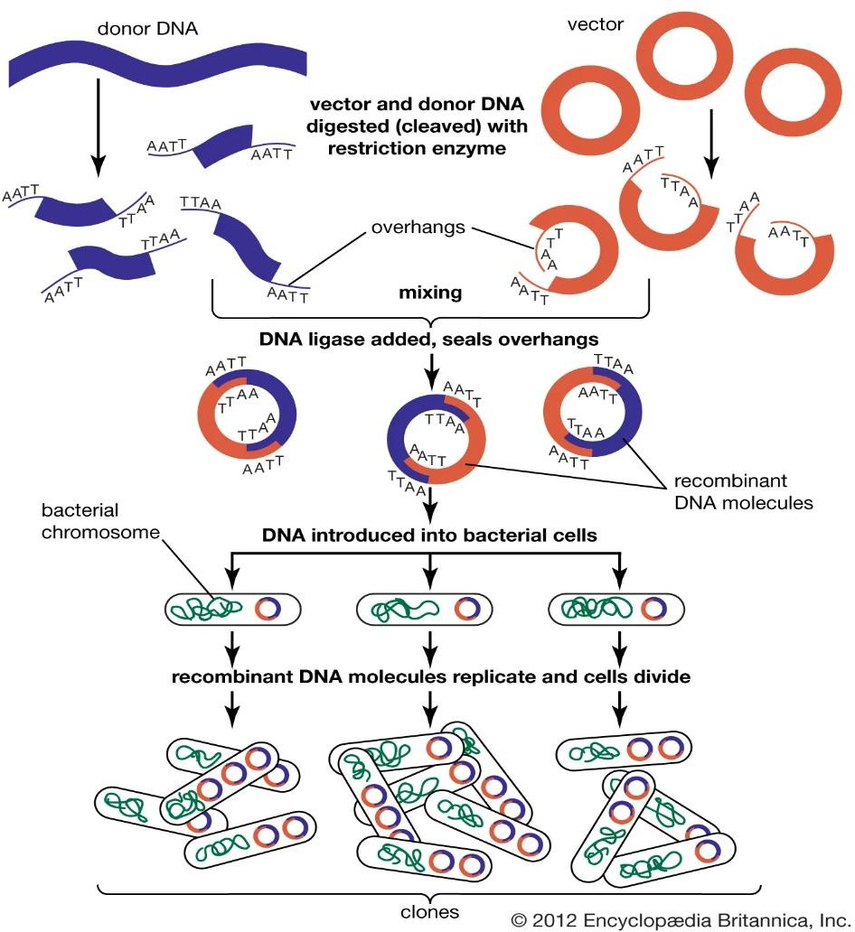

Tools used in Recombinant DNA Technology

- Restriction Enzymes: are endonucleases isolated from bacteria which cleaves DNA at sequence-specific sites producing DNA fragments with a known sequence at each end. They are also called molecular scissors with over 400 currently known. There are four recognized restriction enzymes namely Types I, II, III and IV but in recombinant DNA Type II restriction enzymes are most popularly used due to their ability to recognize and cleave DNA at specific sites.
Every restriction enzyme recognizes a short, specific sequence of nucleotide bases called recognition or restriction sites randomly distributed throughout the DNA. These sites are 4 to 8 nucleotides long and exhibit palindromic symmetry i.e. nucleotide pair sequences are the same reading forward and backward.
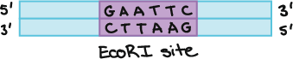

Restriction enzymes cut DNA molecules by cleavage, this action occurs in two ways, sticky or cohesive end and blunt end.
Sticky ends – are made when restriction enzymes (e.g. Eco RI, Bam HI, Hind III) make single strand cut some nucleotide pairs apart in the opposite DNA strands generating fragments with protruding ends.
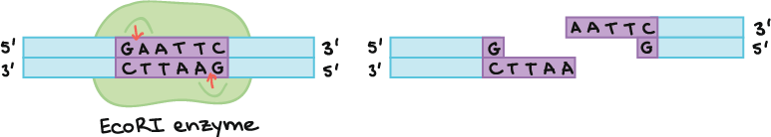

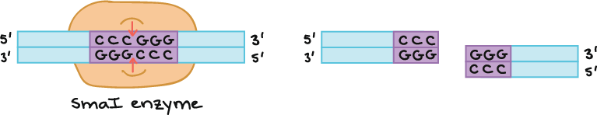
Blunt ends – are made when restriction enzymes (e.g. Hae III, Sma I) makes a cut across both strands of DNA at the same position.

Sticky end DNAs are more useful in recombinant DNA technology because it facilitates ligation easier by forming hydrogen bonds between complementary bases of both strands.

- Vectors: are DNA molecules, usually plasmid or virus, that act as a vehicle to carry specific DNA fragments into a host cell. They are low molecular weight DNA molecules capable of multiplying independently of the genomic DNA. Due to their large copy number, plasmids and bacteriophages are the most commonly employed vectors in rDNA technology. Vectors are made up of an origin of replication; a nucleotide sequence where replication begins, a selectable marker; which are genes that show antibiotic resistance such as ampicillin resistance, and cloning sites; which are sites recognized by restriction enzymes where desired DNAs are inserted. Examples of vectors include Plasmids (PBR 322, PBR 325, etc.), Viruses (Bacteriophage), Cosmids, Bacterial artificial chromosome (BAC), Yeast artificial chromosome.

- DNA Ligases: is a group of enzymes which mediate annealing, sealing, or joining of DNA fragments. DNA ligase is isolated from E. coli and the bacterial virus (T4 phage). Primarily, these enzymes are involved in the repair of DNA where sealing or union of DNA fragments takes place. They also play an active role in DNA replication and combination. Due to their ability to join DNA fragments or seal the nicks in the DNA chain, they are called molecular sutures. To ligate blunt-ended DNA which is harder due to the absence of single strand overhangs to hold the DNA in place, concentrations of DNA and ligase must be high. Blunt ended DNA ligation is a useful way of joining together DNA fragments produced by different restriction enzymes with incompatible sticky ends. These ends are removed prior to ligation, using the enzyme S1 nuclease which digests single-stranded DNA.

Applications of Recombinant DNA technology
  - Gene Therapy: In the treatment of genetic disorders by introducing normal healthy functional genes with the help of genetic engineering or recombinant DNA technology.
  - Creation of Transgenic Organisms: Genetically modified plants, animals and microorganisms are produced with the aid of recombinant DNA technology.
  - Vaccine and drug Production: Several vaccines and important compounds such as insulin, epidermal growth factor, blood clotting factors etc. are produced with this technology.
  - Diseases Diagnosis – Recombinant DNA has been used in the development of the most common diagnostic techniques for HIV.
  - Recombinant proteins are widely used as reagents in laboratory experiments and to generate antibody probes for examining protein synthesis within cells.
  - Recombinant DNA is used to identify, map and sequence genes, and to determine their function.

